# – Demographic & Recreation Trends Analysis

## Introduction

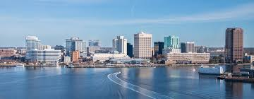A key component of the Master Plan (“Plan”) is a Demographic & Recreation Trends Analysis. This provides the Department of Recreation, Parks, and Open Space (“Department”) insight into the general makeup of the population served and identifies market trends in recreation. It also helps quantify the market for recreation in and around the City of Norfolk (“City”) and understand of the types of parks, facilities, waterfront opportunities, and programs / services that are most appropriate to satisfy the needs of residents.

This analysis is two-fold – it aims to answer the *who* and the *what*. First, it assesses the demographic characteristics and population projections of City residents to understand *who* the Department serves. Secondly, recreational trends are examined on a national, regional, and local level to understand *what* the population served wants to do. Findings from this analysis establish a fundamental understanding that provide a basis for prioritizing the community need for parks, trails, facilities, and recreation programs.

## Demographic Analysis

The Demographic Analysis describes the population within the City. This assessment is reflective of the City’s total population and its key characteristics such as age segments, race, ethnicity, and income levels. It is important to note that future projections are based on historical patterns and unforeseen circumstances during or after the time of the analysis could have a significant bearing on the validity of the projected figures.

### Demographic Overview

The infographic below provides an overview of the City populace based on population, age, race / ethnicity, and income.

**POPULATION:**

* **248,416 residents in 2020**
* **0.23% Avg Annual Growth since 2010**
* **254,994 residents in 2035**

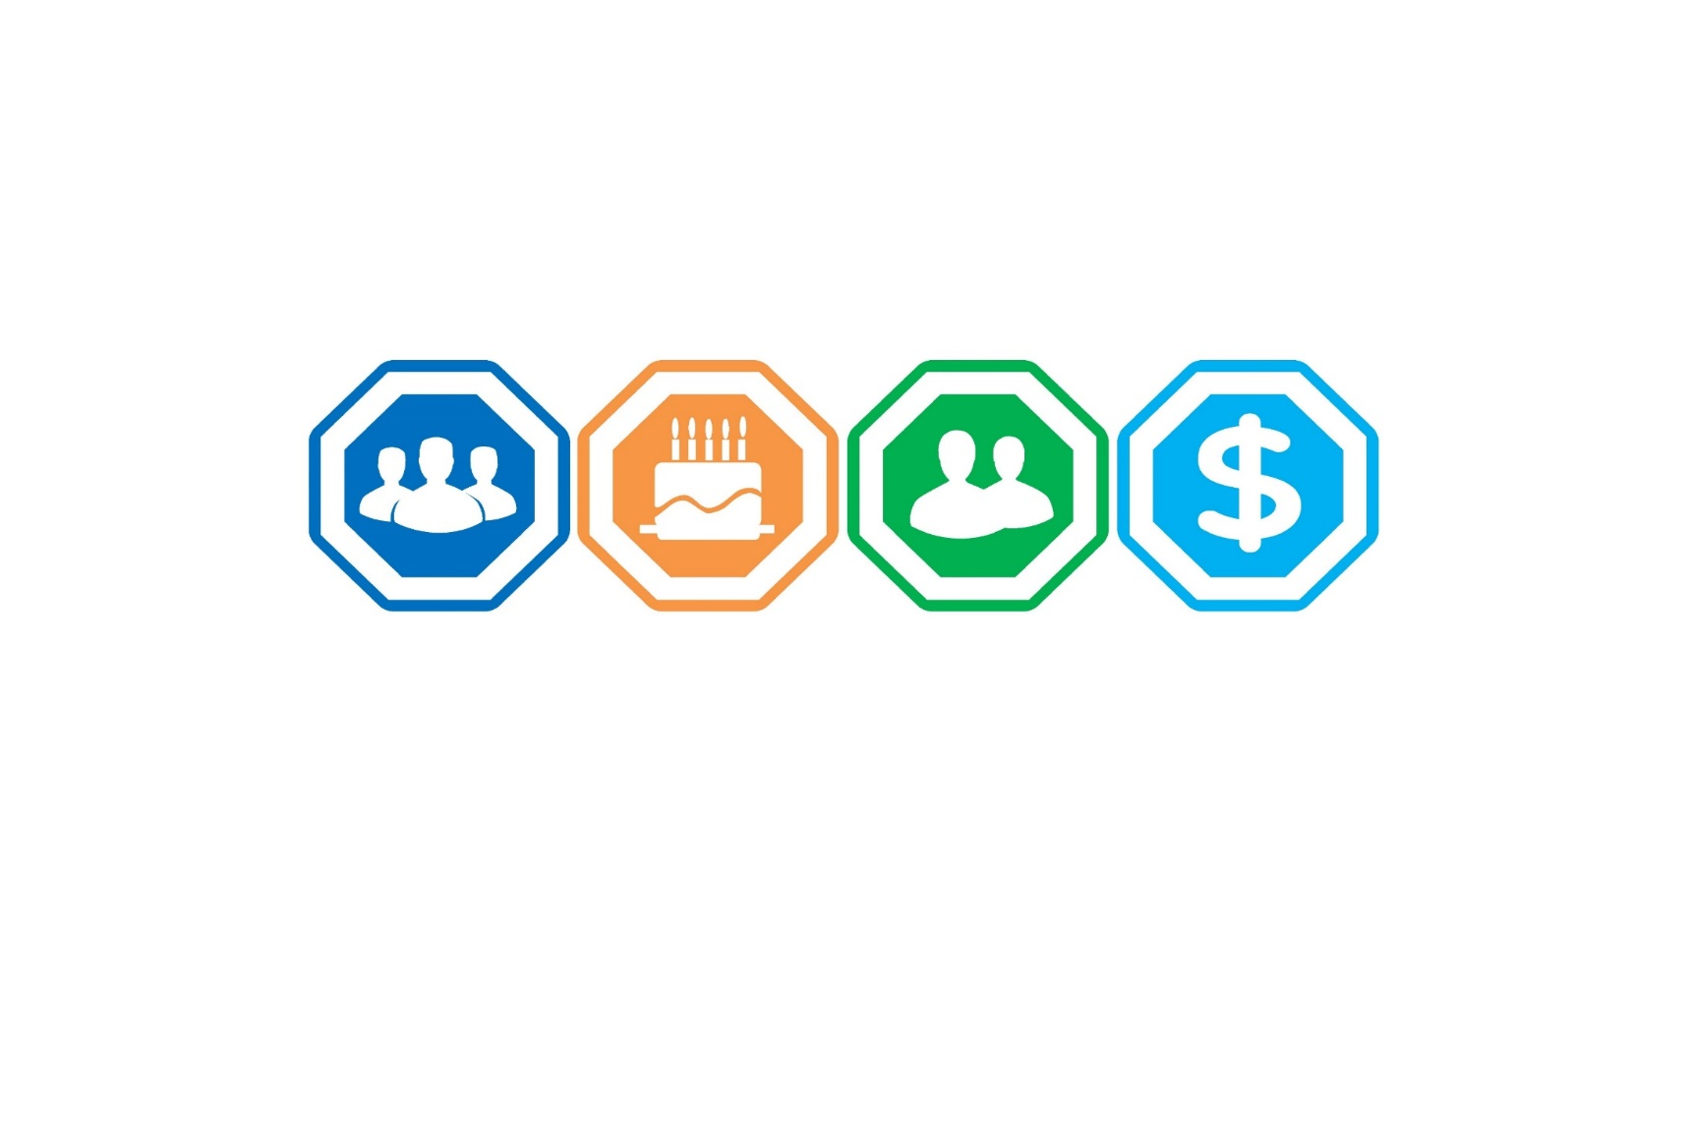

**AGE**

* **Median age: 31.0**
* **Largest age segment: 18-34 )**
* **55+ slow increase by 2035**

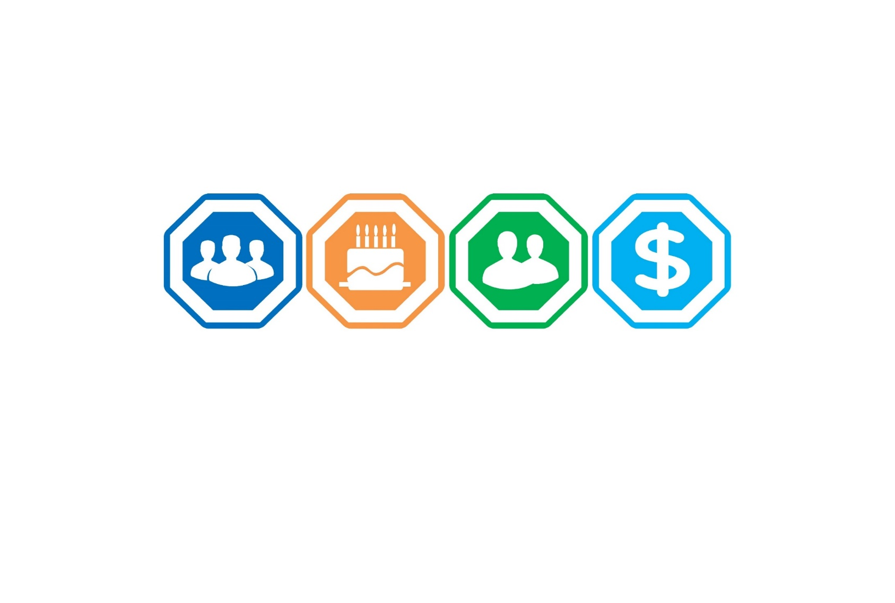

**RACE/ETHNICITY**

* **45% White**
* **43% Black / African American**
* **9% Hispanic / Latino**

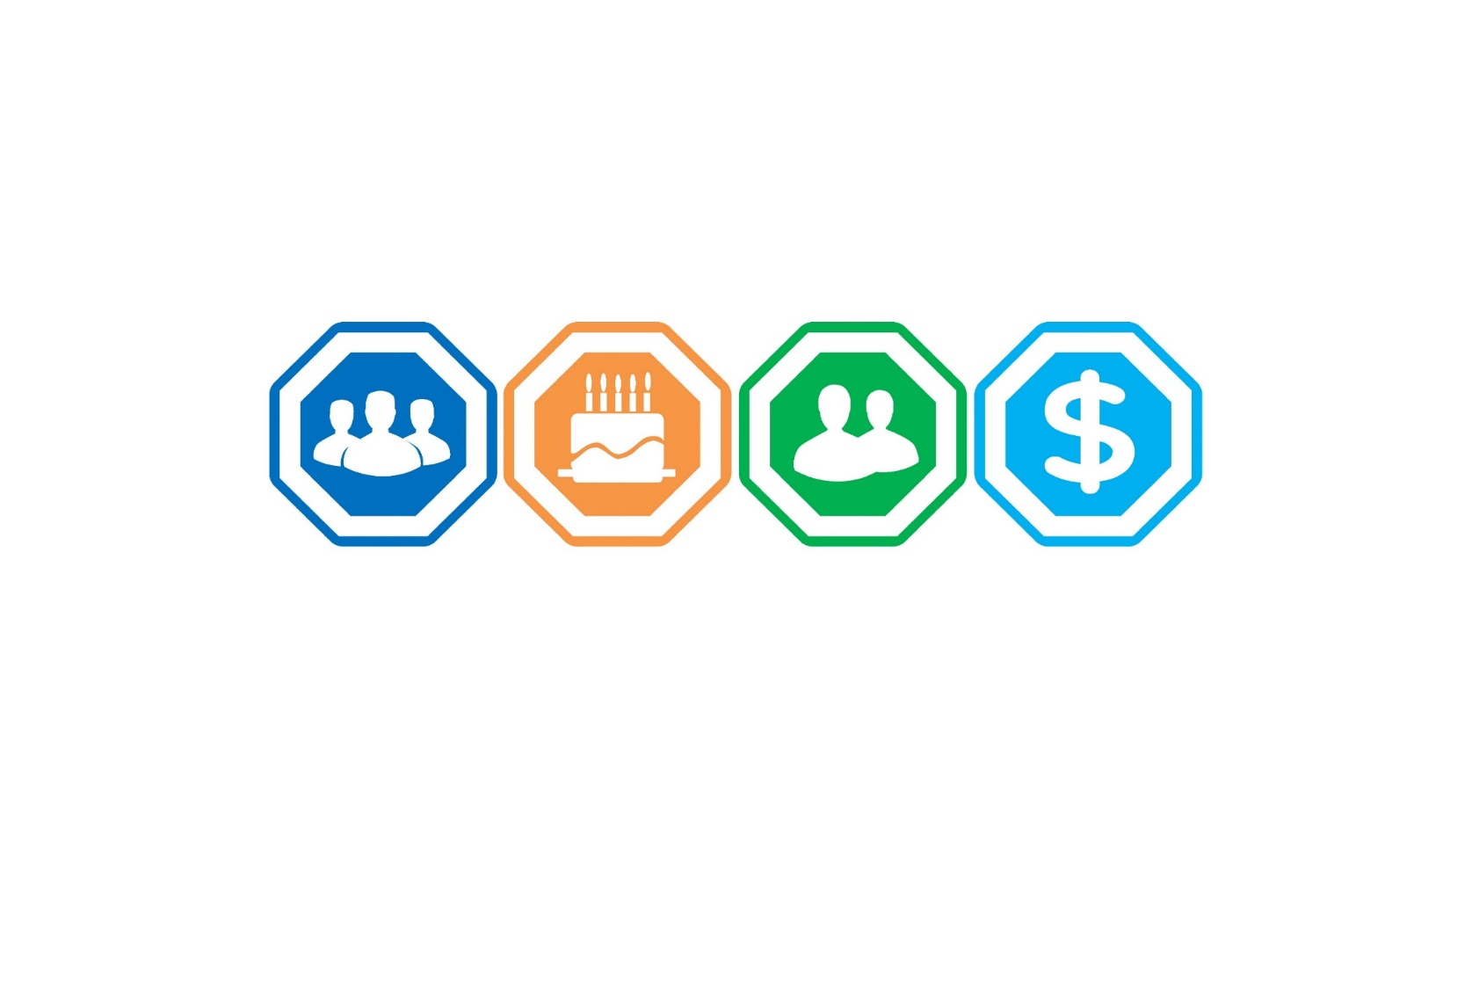

**INCOME**

* **Median household income: $50,260**
* **Per capita income: $27,169**



### Methodology

Demographic data used for the analysis was obtained from U.S. Census Bureau and from Environmental Systems Research Institute, Inc. (ESRI), the largest research and development organization dedicated to Geographical Information Systems (GIS) and specializing in population projections and market trends. All data was acquired in December 2020 and reflects actual numbers as reported in the 2010 Census. ESRI then estimates the current population (2020) as well as a 5-year projection (2025). PROS utilized straight line linear regression to forecast demographic characteristics for 2030 and 2035.

#### Demographic Analysis Boundary

The City boundaries shown below were utilized for the demographic analysis.

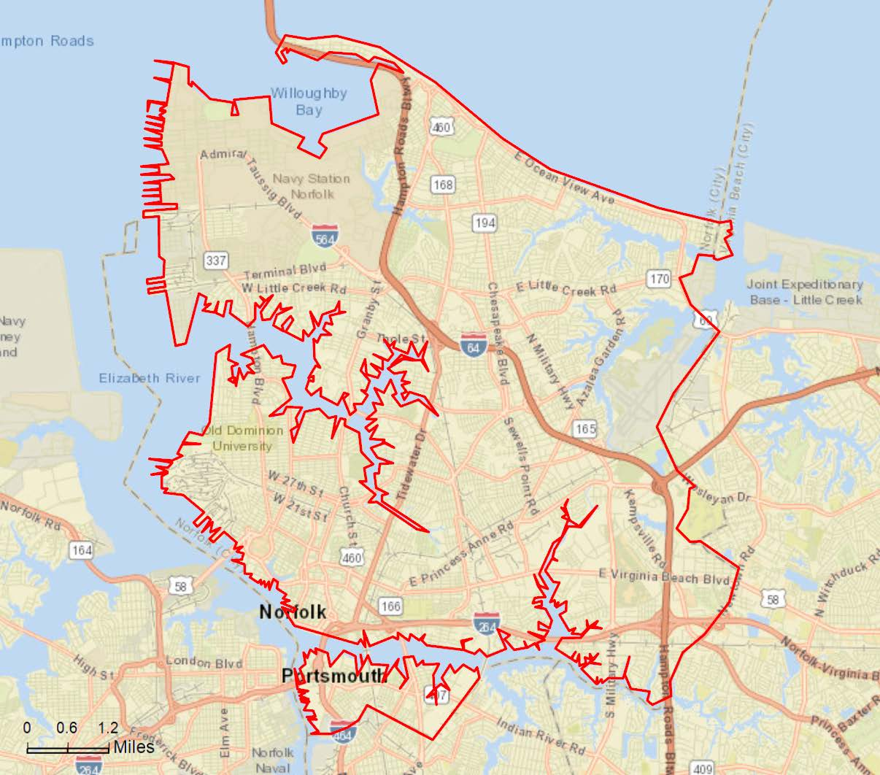

### City Populace

#### Population

The City’s population has experienced a minimal growing trend in recent years, increasing only 2.31% from 2010 to 2020 (0.23% per year). This is lower than the national annual growth rate of 0.81% (from 2010-2020). Similar to the population, the total number of households also experienced a slight increase of 2.10% over the past decade (0.21% annually).

Currently, the population is estimated at 248,416 individuals living within 88,298 households. Projecting ahead, the total population and total number of households are both expected to continue growing at a slow rate over the next 15 years. By 2035, the City’s population is projected at 254,994 residents living within 90,548 households.





#### Age Segment

Evaluating the City’s age segmentation, the population is very young with 56% of residents under the age of 35-years old. The population has a median age of 31 years old which is significantly younger than the U.S. median age of 38.5 years. The younger than average population can be partially attributed to the presence of universities within the City (where Old Dominion University and Norfolk State University have total enrollment of more than 30,000 students) as well as the Naval Station Norfolk. Although the population is much younger than average, the 55-74 and 75+ segments are the only groups projected to experience growth over the next 15 years. By 2034, the 55-74 and 75+ segments are expected to increase to represent 28% of the total population while all other age segments experience small decreases.



#### Race and Ethnicity Definitions

The minimum categories for data on race and ethnicity for Federal statistics, program administrative reporting, and civil rights compliance reporting are defined as below. The Census 2010 data on race are not directly comparable with data from the 2000 Census and earlier censuses; therefore, caution must be used when interpreting changes in the racial composition of the US population over time. The latest (Census 2010) definitions and nomenclature are used within this analysis.

* **American Indian** **–** This includes a person having origins in any of the original peoples of North and South America (including Central America), and who maintains tribal affiliation or community attachment
* **Asian** – This includes a person having origins in any of the original peoples of the Far East, Southeast Asia, or the Indian subcontinent including, for example, Cambodia, China, India, Japan, Korea, Malaysia, Pakistan, the Philippine Islands, Thailand, and Vietnam
* **Black –** This includes a person having origins in any of the black racial groups of Africa
* **Native Hawaiian or Other Pacific Islander** – This includes a person having origins in any of the original peoples of Hawaii, Guam, Samoa, or other Pacific Islands
* **White –** This includes a person having origins in any of the original peoples of Europe, the Middle East, or North Africa
* **Hispanic or Latino –** This is an ethnic distinction, a subset of a race as defined by the Federal Government; this includes a person of Mexican, Puerto Rican, Cuban, South or Central American, or other Spanish culture or origin, regardless of race

*Please Note: The Census Bureau defines Race as a person’s self-identification with one or more of the following social groups: White, Black or African American, Asian, American Indian and Alaska Native, Native Hawaiian and Other Pacific Islander, some other race, or a combination of these. While Ethnicity is defined as whether a person is of Hispanic / Latino origin or not. For this reason, the Hispanic / Latino ethnicity is viewed separate from race throughout this demographic analysis.*

#### Race

Analyzing race, the City’s current population is primarily split between White Alone (45%) and Black / African American (43%). The 2020 estimate also shows a small representation of Asian (4%) and Two or More Races (4%) populations. The City is much more diverse than the national population, which is approximately 70% White Alone, 13% Black Alone, and 7% Some Other Race. The predictions for 2035 expect the population to remain fairly consistent, with a slight decrease in the White Alone population offset by a minimal increase among Two or More Races.



#### Ethnicity

The City’s population was also assessed based on Hispanic/Latino ethnicity, which by the Census Bureau definition is viewed independently from race. It is important to note that individuals who are Hispanic/Latino in ethnicity can also identify with any racial categories above.

Based on the 2010 Census, people of Hispanic/ Latino origin represent approximately 7% of the City’s current population, which is significantly less than the national average (19% Hispanic/Latino). The Hispanic/ Latino population is expected to grow more rapidly than any race, as it will increase to 11% of the City’s total population by 2035.



#### Household Income

As seen below, the City’s per capita income ($27,169) and median household income ($50,260) are both significantly lower than state and national averages. The below average income characteristics may indicate that the average resident has less disposable income and may be more price sensitive to recreational offerings through the Department.



### Demographic Comparative Summary

The table below is a summary of the City’s demographic figures. These figures are then compared to the state and U.S. populations for perspective on a regional and national scale. The highlighted cells represent key takeaways from the comparison between the City and the national population.

= Significantly higher than the National Average

= Significantly lower than the National Average



## Recreational Trends Analysis

The Trends Analysis provides an understanding of national, and local recreational trends. Trends data used for this analysis was obtained from Sports & Fitness Industry Association’s (“SFIA”), National Recreation and Park Association (“NRPA”), and ESRI. All trends data is based on current and/or historical participation rates or statistically-valid survey results.

### National Trends in Recreation

#### Methodology

The SFIA’s *Sports, Fitness & Recreational Activities Topline Participation Report 2020* was utilized in evaluating the following trends:

* National Recreation Participatory Trends
* Core vs. Casual Participation Trends

The study is based on findings from surveys carried out in 2019 by the Physical Activity Council (“PAC”), resulting in a total of 18,000 online interviews. Surveys were administered to all genders, ages, income levels, regions, and ethnicities to allow for statistical accuracy of the national population. A sample size of 18,000 completed interviews is considered by SFIA to result in a high degree of statistical accuracy. A sport with a participation rate of five percent has a confidence interval of plus or minus 0.32 percentage points at a 95 percent confidence level. Using a weighting technique, survey results are applied to the total U.S. population figure of 302,756,603 people (ages six and older).

The purpose of the report is to establish levels of activity and identify key participatory trends in recreation across the U.S. This study looked at 122 different sports/activities and subdivided them into various categories including: sports, fitness, outdoor activities, aquatics, etc.

#### Core vs. Casual Participation

In addition to overall participation rates, SFIA further categorizes active participants as either core or casual participants based on frequency of participation. Core participants have higher participatory frequency than casual participants. The thresholds that define casual versus core participation may vary based on the nature of each individual activity. For instance, core participants engage in most fitness activities more than 50-times per year, while for sports, the threshold for core participation is typically 13-times per year.

In a given activity, core participants are more committed and tend to be less likely to switch to other activities or become inactive (engage in no physical activity) than causal participants. This may also explain why activities with more core participants tend to experience less pattern shifts in participation rates than those with larger groups of casual participants.

### National Sport and Fitness Participatory Trends

#### National Trends in general sports

The sports most heavily participated in the United States were Basketball (24.9 million) and Golf (24.3 million), which have participation figures well in excess of the other activities within the general sports category. Followed by Tennis (17.7 million), Baseball (15.8 million), and Outdoor Soccer (11.9 million).

The popularity of Basketball, Golf, and Tennis can be attributed to the ability to compete with relatively small number of participants. Basketball’s success can also be attributed to the limited amount of equipment needed to participate and the limited space requirements necessary, which make basketball the only traditional sport that can be played at the majority of American dwellings as a drive-way pickup game. Even though Golf has experienced a recent decrease in participation in the last 5-years, it still continues to benefit from its wide age segment appeal and is considered a life-long sport. In Addition, target type game venues or Golf Entertainment Venues (e.g. Top Golf) have increased drastically (84.7%) as a 5-year trend. The emergence of Golf Entertainment, such as Top Golf, has helped increase participation for golf as an activity outside of traditional golf course environments.



**Basketball**

**24.9 Million**

**Golf**

**24.3 Million**

**Tennis**

**17.7 Million**

**Baseball**

**15.8 Million**

**Soccer**

**11.9 Million**

##### Five-Year Trend

Since 2014, Golf Entertainment Venues (84.7%), Pickleball (40.5%), and Flag Football (23.1%) have emerged as the overall fastest growing sports. During the last five-years. Similarly, Baseball (20.2%) and Indoor Soccer (17.8%) have also experienced significant growth. Based on the trend from 2014-2019, the sports that are most rapidly declining include Ultimate Frisbee (-49.4%), Squash (-23.4%), Touch Football (-21.5%), Badminton (-15.1%), and Tackle Football (-14.6%).

##### One-Year Trend

In general, the most recent year shares a similar pattern with the five-year trends; with Boxing for Competition (8.2%), Golf- Entertainment Venues (6.7%), and Pickleball (4.8%) experiencing the greatest increases in participation this past year. However, some sports that increased rapidly over the past five years have experienced recent decreases in participation, such as Rugby (-10.8%) and Gymnastics (-1.5%). Other sports including Ultimate Frisbee (-15.5%), Sand Volleyball (-7.8%), Roller Hockey (-6.8%), and Touch Football (-6.3) have also seen a significant decrease in participate over the last year.

##### Core vs. Casual Trends in general sports

Highly participated in sports, such as Basketball, Baseball, and Slow Pitch Softball, have a larger core participant base (participate 13+ times per year) than casual participant base (participate 1-12 times per year). In the past year, Ice Hockey and Softball -Fast Pitch have increased core participation. While less mainstream sports, such as Boxing for Competition, Roller Hockey, Badminton, and Racquetball have larger casual participation base. These participants may be more inclined to switch to other sports or fitness activities. *Please see the* ***Appendix*** *for full Core vs. Casual Participation breakdown.*



#### National trends in general fitness

Overall, national participatory trends in fitness have experienced strong growth in recent years. Many of these activities have become popular due to an increased interest among Americans to improve their health and enhance quality of life by engaging in an active lifestyle. These activities also have very few barriers to entry, which provides a variety of options that are relatively inexpensive to participate in and can be performed by most individuals. The most popular general fitness activities amongst the U.S. population include: Fitness Walking (111.4 million), Treadmill (56.8 million), Free Weights (51.4 million), Running/Jogging (49.5 million), and Stationary Cycling (37.1 million).

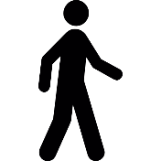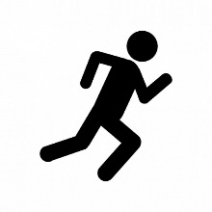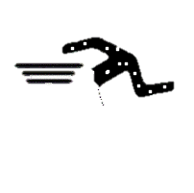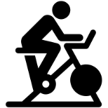

**Fitness Walking**

**111.4 Million**

**Treadmill**

**56.8 Million**

**Dumbbell**

**Free Weights**

**51.4 Million**

**Running/ Jogging**

**49.5 Million**

**Stationary Cycling**

**37.1 Million**



##### Five-Year Trend

Over the last five years (2014-2019), the activities growing most rapidly are Trail Running (46.0%), Yoga (20.6%), Cross Training Style Workout (20.2%), and Stationary Group Cycling (17.5%). Over the same time frame, the activities that have undergone the biggest decline include: Traditional Triathlon (-9.2%), Running/Jogging (-8.7%), Free Weights (-8.3%), and Fitness Walking (-1.0%)

##### One-Year Trend

In the last year, activities with the largest gains in participation were Trail Running (9.9%), Dance, Step, & Choreographed Exercise (7.0%), and Yoga (6.0%). From 2018-2019, the activities that had the largest decline in participation were Traditional Triathlons (-7.7%), Non-Traditional Triathlon (-7.4%), Bodyweight Exercise (-2.8%), and Running/Jogging (-2.6%).

##### Core vs. Casual trends in general fitness

The most participated in fitness activities all have a strong core users base (participating 50+ times per year). These fitness activities include: Fitness Walking, Treadmill, Free Weights, Running/Jogging, Stationary Cycling, Weight/Resistant Machines, and Elliptical Motion/Cross Training, all having 48% or greater core users. *Please see the* ***Appendix*** *for full Core vs. Casual Participation breakdown.*



#### national trends in Outdoor recreation

Results from the SFIA report demonstrate a contrast of growth and decline in participation regarding outdoor/adventure recreation activities. Much like the general fitness activities, these activities encourage an active lifestyle, can be performed individually or within a group, and are not as limited by time constraints. In 2019, the most popular activities, in terms of total participants, from the outdoor/adventure recreation category include: Day Hiking (49.7 million), Road Bicycling (39.4 million), Freshwater Fishing (39.2 million), and Camping within ¼ mile of Vehicle/Home (28.2 million), and Recreational Vehicle Camping (15.4 million).

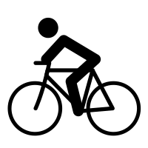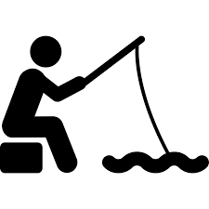

**Hiking**

**(Day)**

**49.7 Million**

**Bicycling**

**(Road)**

**39.4 Million**

**Fishing**

**(Freshwater)**

**39.2 Million**

**Camping**

**(<¼mi. of Car/Home)**

**28.2 Million**

**Camping**

**(Recreational Vehicle)**

**15.4 Million**

##### Five-Year Trend

From 2014-2019, BMX Bicycling (55.2%), Day Hiking (37.2%), Fly Fishing (20.1%), Salt Water Fishing (11.6%), and Mountain Bicycling (7.2%) have undergone the largest increases in participation. The five-year trend also shows activities such as In-Line Roller Skating (-20.5%), Archery (-11.7%), and Adventure Racing (-9.5%) experiencing the largest decreases in participation.

##### One-Year Trend

The one-year trend shows activities growing most rapidly being BMX Bicycling (6.1%), Day Hiking (3.8%), and Birdwatching (3.8%). Over the last year, activities that underwent the largest decreases in participation include: Climbing (-5.5%), In-Line Roller Skating (-4.4%), and Camping with a Recreation Vehicle (-3.5%).

##### Core vs. Casual trends in Outdoor recreation

A majority of outdoor activities have experienced participation growth in the last five- years. Although this a positive trend, it should be noted that all outdoor activities participation, besides adventure racing, consist primarily of casual users. This is likely why we see a lot of fluctuation in participation numbers, as the casual users likely found alternative activities to participate in. *Please see the* ***Appendix*** *for full Core vs. Casual Participation breakdown.*



#### National Trends in Aquatics

Swimming is deemed as a lifetime activity, which is most likely why it continues to have such strong participation. In addition, in a watefront community like Norfolk, it is also critical as a life-saving skill particularly for those from primarily African American and Hispanic / Latino communities that have shown to have a higher than average incidence of drowning. In 2019, Fitness Swimming was the absolute leader in overall participation (28.2 million) amongst aquatic activities, largely due to its broad, multigenerational appeal.

**Swimming**

**(Fitness)**

**28.2 Million**

**Aquatic Exercise**

**11.2 Million**

**Swimming**

**(Competition)**

**2.8 Million**

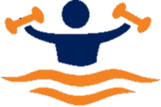

##### Five-Year Trend

Assessing the five-year trend, all aquatic activities have experienced growth. Aquatic Exercise stands out having increased (22.7%) from 2014-2019, most likely due to the ongoing research that demonstrates the activity’s great therapeutic benefit, followed by Fitness Swimming (11.5%) and Competition Swimming (4.1%).

##### One-Year Trend

From 2018-2019, Competitive Swimming (-7.3%) was the only aquatic activity that declined in participation. While both Aquatic Exercise (6.4%) and Fitness swimming (2.3%) experienced increases when assessing their one-year trend.

##### Core vs. Casual Trends in Aquatics

All aquatic activities have undergone increases in participation over the last five years, primarily due to large increases in casual participation (1-49 times per year). From 2014 to 2019, casual participants for Aquatic Exercise (35.7%), Competition Swimming (22.7%), and Fitness Swimming (18.4%) have all grown significantly. However, all core participation (50+ times per year) for aquatic activities have decreased over the last five-years. *Please see the* ***Appendix*** *for full Core vs. Casual Participation breakdown.*



#### National Trends in Water Sports / Activities

The most popular water sports / activities based on total participants in 2019 were Recreational Kayaking (11.4 million), Canoeing (8.9 million), and Snorkeling (7.7 million). It should be noted that water activity participation tends to vary based on regional, seasonal, and environmental factors. A region, such as Norfolk, with more water access and a warmer climate is more likely to have a higher participation rate in water activities than a region that has a long winter season or limited water access. Therefore, when assessing trends in water sports and activities, it is important to understand that fluctuations may be the result of environmental barriers which can greatly influence water activity participation.

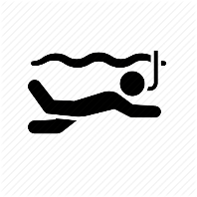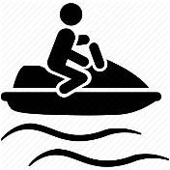

**Kayaking**

**11.4 Million**

**Canoeing**

**9.0 Million**

**Snorkeling**

**7.7 Million**

**Jet Skiing**

**5.1 Million**

**Sailing**

**3.6 Million**

##### Five-Year Trend

Over the last five years, Stand-Up Paddling (29.5%) and Recreational Kayaking (28.5%) were the fastest growing water activity, followed by White Water Kayaking (9.9%) and Surfing (8.9%). From 2014-2019, activities declining in participation most rapidly were Water Skiing (-20.1%), Jet Skiing (-19.6%), Scuba Diving (-13.7%), Wakeboarding (-12.7%), and Snorkeling (-12.5%).

##### One-Year Trend

Similarly, to the five-year trend, Recreational Kayaking (3.3%) and Stand-Up Paddling (3.2%) also had the greatest one-year growth in participation, from 2018-2019. Activities which experienced the largest decreases in participation in the most recent year include: Boardsailing/Windsurfing (-9.7%), Sea Kayaking (-5.5), and Water Skiing (-4.8%)

##### Core VS. CASUAL trends in Water Sports/Activities

As mentioned previously, regional, seasonal, and environmental limiting factors may influence the participation rate of water sport and activities. These factors may also explain why all water-based activities have drastically more casual participants than core participants, since frequencies of activities may be constrained by uncontrollable factors. These high casual user numbers are likely why a majority of water sports/activities have experienced decreases in participation in recent years. *Please see the* ***Appendix*** *for full Core vs. Casual Participation breakdown.*



### Local Sport and Leisure Market Potential

#### The following charts show sport and leisure market potential data for City residents, as provided by ESRI. Market Potential Index (MPI) measures the probable demand for a product or service within the defined service areas. The MPI shows the likelihood that an adult resident will participate in certain activities when compared to the U.S. national average. The national average is 100; therefore, numbers below 100 would represent lower than average participation rates, and numbers above 100 would represent higher than average participation rates. The service area is compared to the national average in four (4) categories – general sports, fitness, outdoor activity, and commercial recreation.

#### MPI scores are a tool that the Department can use for consideration when starting new programs or developing new facilities and amenities. The market potential gives the Department a starting point for estimating resident attendance and participation for a broad set of recreational activities.

#### MPIs for City residents demonstrate strong market potential figures for all four categories that were assessed. The top five activities based on MPI were Visiting a Zoo (140), Tennis (138), Soccer (136), Football (134), and Dancing (132). Less than 15% of all activities assessed had MPI scores below the national average, which suggests the local population is very inclined to participate in recreational activities.

#### The following charts compare MPI scores for 42 sport and leisure activities that are prevalent for residents within the City. The activities are categorized by activity type and listed in descending order, from highest to lowest MPI score. High index numbers (100+) are significant because they demonstrate that there is a greater likelihood that residents within the service areas will actively participate in offerings provided by the Department.

#### General Sports Market Potential

The General Sports category has the highest overall MPI figures, as all activities have above average MPI scores. Activities that have the greatest market potential are Tennis (138), Soccer (136), and Football (134).



#### Fitness Market Potential

All but one activity in the Fitness category have above average MPI scores. The top three activities in this category include Pilates (129), Jogging / Running (116), and Zumba (114). Walking for Exercise (88) has the lowest MPI of all activities assessed, though in this case, it may be caused by lack of access to walking trails and connectivity than the lack of desire of the City’s members to walk.



#### Outdoor Activity Market Potential

Assessing MPI scores for the Outdoor Activity Category reveals only two activities that fall below average MPI (Horseback Riding and Freshwater Fishing). The top activities based on MPI were Backpacking (131), Salt Water Fishing (114), and Road Bicycling (109).



#### Commercial Recreation Market Potential

The Commercial Recreation category also reveals a vast majority of activities with MPI scores above the national average. Visited a Zoo (140) had the highest MPI of all activities in this study, followed by Danced / Went Dancing (132), and Painting / Drawing (116).



## Demographics & Trends Key Findings

Based on the information presented in the Demographics & Trends Analysis, the following key findings are of particular interest and/or have significant implications for the Department:

* **Population:** The City population is growing slowly, at a rate of one-fourth of the national growth rate. As the population increases, the Department must pay attention to demographic shifts in the future to ensure that offerings continue to evolve to meet the changing community needs.
* 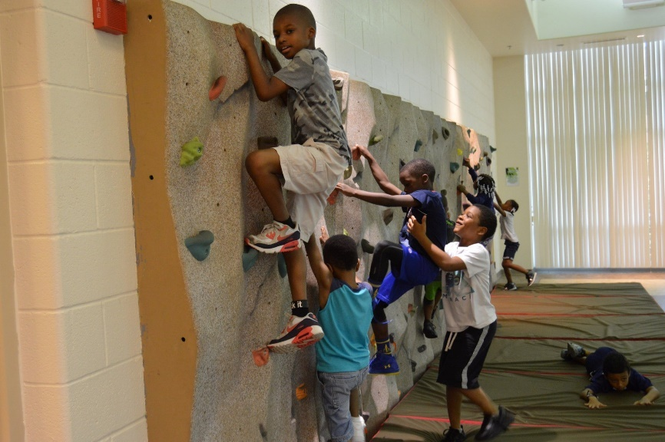**Age:** City residents are much younger than the national median age and there is a strong presence of young adults ages 18-34. By 2035, the oldest age segments (55-74 and 75+) are expected to be the only groups that will experience growth. The Department must continue to provide services for all ages and regularly reevaluate its programming mix to effectively transition as the population ages.
* **Race / Ethnicity:** The City’s populace is more diverse than the national landscape, with a nearly even split between White Alone (45%) and Black / African American (43%) races. The US is 70% White Alone and 13% Black / African American. The racial composition of City residents is expected to remain fairly consistent over the next 15 years. People of Hispanic / Latino ethnicity represent only 9% of the total population, which is half of the national average (18.8%), but this group is expected to undergo slight growth by 2035. The Department should continue to monitor program participation to ensure that offerings are adequately serving residents and are representative of the race / ethnicity distribution of City residents.
* **Income Levels:** The income characteristics of City residents are well below state and national levels for per capita income and median household income. The lower earning capabilities of the population suggests there may be areas that are facing significant limitations financially and a general lack of disposable income for residents. The Department should pay close attention the pricing and access to recreational opportunities, especially for populations prone to lower income, and ensure offerings are equitable. Households with lower income may also be more susceptible to barriers for participation, such as transportation and access to technology.
* **National Participatory Trends:** National participatory trends are promising for the Department, as many of the activities in sports and fitness aligned with core offerings are trending positively in recent years. Despite the facility closures due to the pandemic, in general, people are recreating more and the importance of living an active, healthy lifestyle is on the rise. The City must continue to provide active recreation opportunities and seek out new, trending activities that will pique interest and meet the demand for parks, facilities, and recreation programs among City residents for many years to come.
* **Local Participatory Trends:** Local recreation trends show strong participation across all categories assessed, with only 6 out of 42 activities having MPI scores below the national average. This is very promising for the Department, as market potential data suggests that City residents are more inclined to participate in a wide variety of recreational activities related to sports, fitness, outdoor recreation, and commercial recreation.

**Appendices**

# APPENDIX A- Non-Participant Interest by Age Segment

In addition to participation rates by generation, SFIA also tracks non-participant interest. These are activities that the U.S. population currently does not participate in due to physical or monetary barriers, but is interested in participating in. Below are the top five activities that each age segment would be most likely to partake in, if they were readily available.

Overall, the activities most age segments are interested in include: Camping, Bicycling, Fishing, and Swimming for Fitness. All of which are deemed as low-impact activities, making them obtainable for any age segment to enjoy.

Fishing

Camping

Soccer

Martial Arts

Basketball

6**-12 Year-Olds**

Camping

Fishing

Martial Arts

Volleyball

Kayaking

**18-24 Year-Olds**

Camping

Fitness Swimming

Bicycling

Fishing

Kayaking

**25-34 Year-Olds**

Fishing

Camping

Working out w/ Weights

Volleyball

Running/Jogging

**13-17 Year-Olds**

Fitness Swimming

Camping

Bicycling

Fishing

Hiking

**35-44 Year-Olds**

Bicycling

Fishing

Fitness Swimming

Camping

Hiking

**55-64 Year-Olds**

Bicycling

Fishing

Camping

Fitness Swimming

Hiking

**45-54 Year-Olds**

Fishing

Fitness Swimming

Bicycling

Birdwatching/Wildlife viewing

Working out using machines

**65+ Year-Olds**

# Appendix B - National and Regional Programming Trends

**Programs offered by Park and Recreation Agencies (Southern Region)**

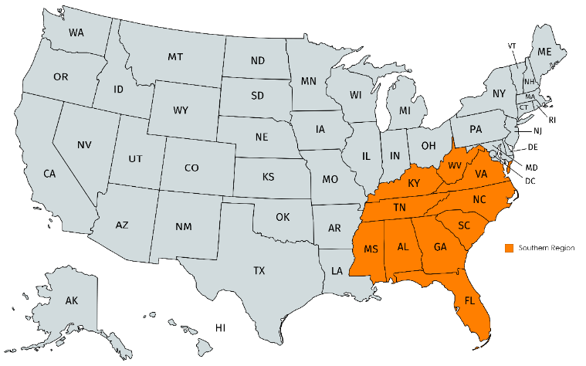NRPA’s *Agency Performance Review 2020* summarize key findings from NRPA Park Metrics, which is a benchmark tool that compares the management and planning of operating resources and capital facilities of park and recreation agencies. The report contains data from 1,053 park and recreation agencies across the U.S. as reported between 2017 and 2019.

Southern

Region

Based on this year’s report, the typical agency (i.e., those at the median values) offers 187 programs annually, with roughly 64% of those programs being fee-based activities/events.

According to the information reported to the NRPA, the top five programming activities most frequently offered by park and recreation agencies, both in the U.S. and regionally, are described in the table below. A complete comparison of regional and national programs offered by agencies can be found on the following page.

When comparing Midwest Region agencies to the U.S. average, team sports, themed special events, social recreation events, and fitness enhancement classes were identified in top five most commonly provided program areas offered regionally and nationally.

|  |  |
| --- | --- |
| Top 5 Most Offered Core Program Areas  (Offered by Parks and Recreation Agencies) | |
| Southern (% of agencies offering) | **U.S. (% of agencies offering)** |
| * Team Sports (87%) | * Themed Special Events (88%) |
| * Social Recreation Events (87%) | * Team Sports (87%) |
| * Themed Special Events (85%) | * Social Recreation Events (87%) |
| * Fitness Enhancement Classes (80%) | * Fitness Enhancement Classes (82%) |
| * Health & Wellness Education (79%) | * Health & Wellness Education (81%) |

Overall, Southern Region parks and recreation agencies are trailing the U.S. average for many program offerings. When utilizing a discrepancy threshold of +/-5% (or more), Midwest agencies are currently offering Aquatics, Performing Arts, Golf, and Safety Training programs at a lesser rate than the national average.



**Targeted Programs for Children, Seniors, and People with Disabilities**

For a better understanding of targeted programs (programs that cater to a specific age segment, demographic, etc.), NRPA also tracks program offerings that are dedicated specifically to children, seniors, and people with disabilities. This allows for further analysis of these commonly targeted populations on a national and regional basis.

|  |  |
| --- | --- |
| Top 3 Most Offered Core Program Areas  (Targeting Children, Seniors, and/or People with Disabilities) | |
| Southern (% of agencies offering) | **U.S. (% of agencies offering)** |
| * Summer Camp (84%) | * Summer Camp (83%) |
| * Senior Programs (79%) | * Senior Programs (78%) |
| * Teen Programs & Programs for People with Disabilities (63%) | * Teen Programs(65%) |

Based on information reported to the NRPA, the top three targeted programs offered by park and recreation agencies, nationally and regionally, are described in the table below, followed by a chart that shows the complete comparison of regional and national targeted program offerings.

Agencies in the Southern Region tend to offer targeted programs both above and below the national average. Southern agencies are currently offering Before School Programs and Preschool at a significantly lower rate than the national average**.**



# Appendix C- Core vs. Casual Participation Trends

## General Sports

## GENERAL SPORTS (Continued)

## General Fitness

## General Fitness (Continued)

## Outdoor/Adventure Recreation

## Aquatics

## Water Sports/Activities

